**Experiment 4**

**Aim:** Create a docker image using Dockerfile. Upload the image created on Dockerhub, also launch a container via the image.

**Procedure:**

**Step 1:** Write the code for the Dockerfile. The code:

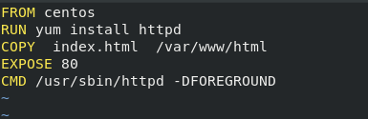

Here the use of the “EXPOSE” command is to expose the 80 port hwre the webserver will execute. This is where the port will be patted with a port from the base system.

The use of the “CMD” command is to start the httpd service. This is the same command as the “systemctl start httpd” command.

**Step 2:** Build the Dockerfile using the **docker build** command. The command:

“docker build –t <nameOfImage>:<version> <location of the Dockerfile>”

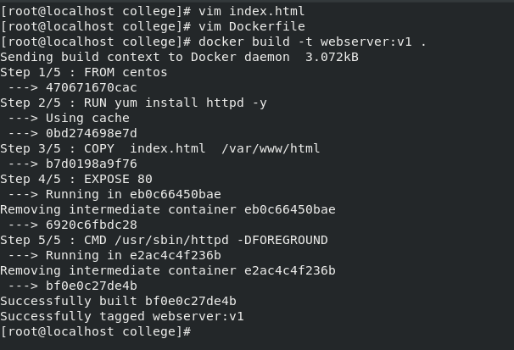

**Step 3:** To push the image created the name of the image has to be changed to the format:

<usernameOnDockerhub>/imagename, so changing the name using the **docker tag** command. The command: “docker tag <currentName> <newName>.” Now push the image on dockerhub using the **docker push** command.

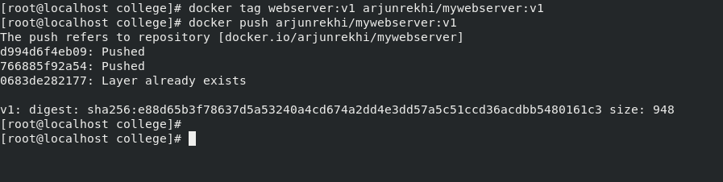

Image has been pushed and can be seen on dockerhub as well:

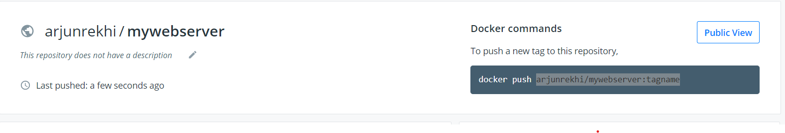

**Step 4:** Launching a container with the image created. The command used: “docker run –dit –p <port>:80 –name <nameOfContainer> <nameOfImage>”.

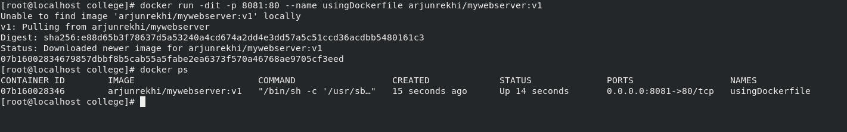

Output as seen on the browser:

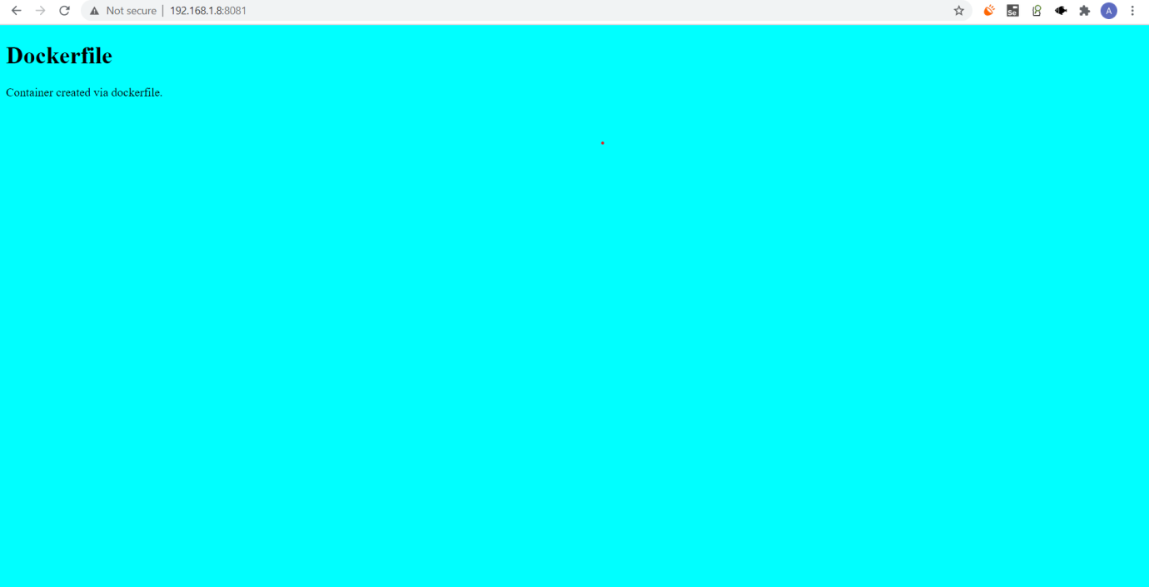

Submitted by:

Arjun Rekhi

500068109

R171218028